EECE 7290 – Software Defined Networking (Spring 2017), University of Massachusetts, Lowell

**Project** - SDN for Secure Video Streaming: CORD Based Secure Video Streaming

**Document** – Setting up CORD in the CloudLab.

**Students** –

1. Aman Maldar
2. Priyanka Murthy

Date of submission – May 5, 2017

This paper walks through instructions for setting up XOS on OpenStack profile on CloudLab and provides technical overview of implementation of a simple HelloWorld service on the XOS platform. [1]

**Steps:**1. Login to CloudLab - <https://www.cloudlab.us/login.php>

2. Go to Experiments 🡪 Start Experiment

3. Follow Select Profile 🡪 Change Profile

Select this profile **OnePC-Ubuntu14.04.4**

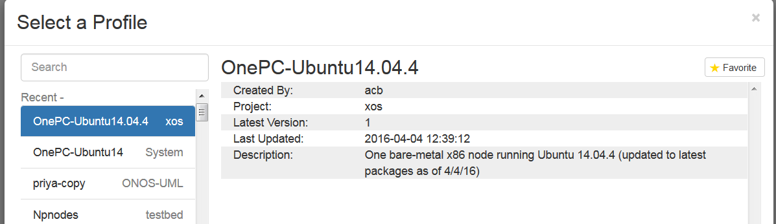

Scroll down and click ‘Select Profile’

Skip the Parameterize tab.

Make following selections on Finalize Tab. And then click Finish.

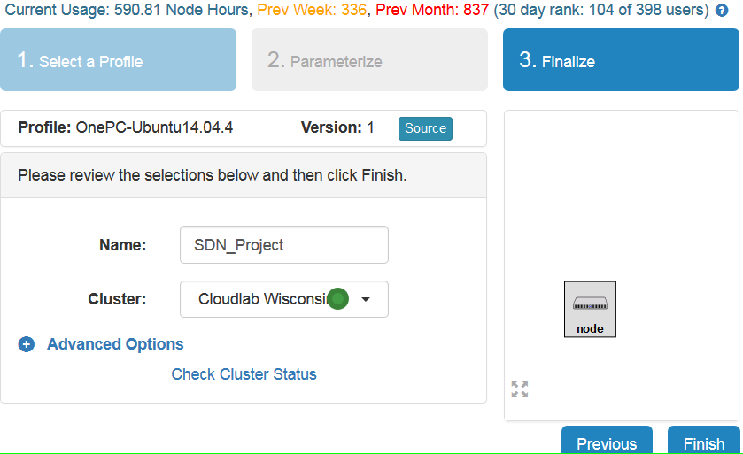

This will take some time (typically 5-10 minutes) to get the experiment ready. See the progress.

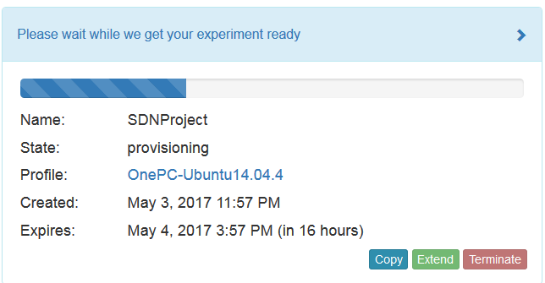Note: Do not proceed to next step until ‘State’ becomes “ready”. It will give error in later step if  
the ‘State’ is “booted (startup services are still running)”.

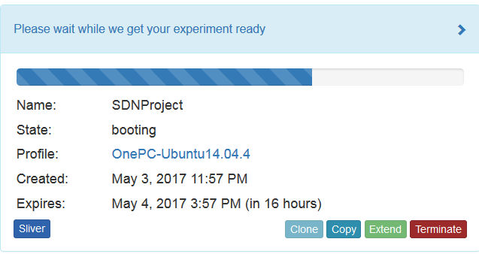

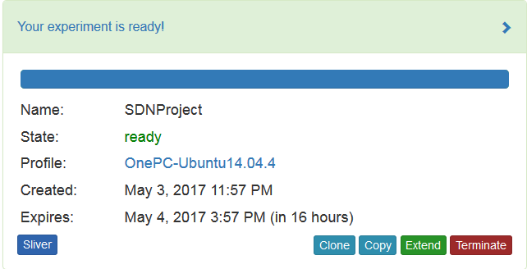

Once the experiment is ready, Click on Extend button to click the experiment to prevent is from expiring.

Scroll Down and see the IP address of the compute node allocated by using following command.

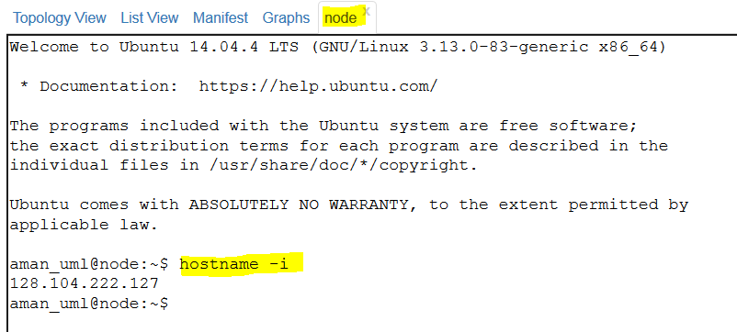

SSH into the node using terminal. (I am using Linux OS Ubuntu 14.04)

Before doing ssh make sure you have set up valid public-private key pair.

**Follow the steps given on link below for generating a new SSH key and adding it to the ssh-agent**

<https://help.github.com/articles/generating-a-new-ssh-key-and-adding-it-to-the-ssh-agent/>

Files are generated in .ssh folder. we have to copy them from **.ssh to home/ubuntu/**  so that we can upload them to the cloudLab portal. Copy the files using following instructions.

cp .ssh/id_rsa.pub ./

cp .ssh/id_rsa ./

Once, above steps are successful we have to ssh into the compute node.

* ssh username@ip_address

ex- ssh [aman_uml@128.104.222.127](mailto:aman_uml@128.104.222.127)

Follow the steps mentioned on <https://github.com/opencord/cord/blob/master/docs/quickstart.md> to setup the XOS and CORD environment.

Steps typically includes,

1. Installing the system requirements first

* sudo apt-get update
* sudo apt-get install screen
* sudo apt-get install curl
* curl -o ~/cord-in-a-box.sh <https://raw.githubusercontent.com/opencord/cord/cord-2.0/scripts/cord-in-a-box.sh>

Execute the screen command as the next process takes approximately 4 hours to complete. We want to detach the screen while the process is being executed.

* screen

(Press space bar 2-3 times)

* bash ~/cord-in-a-box.sh -t | tee ~/install.out

Now press ctrl+A+D to detach the screen.

* Exit

Wait for 4 hours at least. To attach the screen again, we can use following command.

* Screen –r

Check the logs if installation is successful by running following command.

* Cat install –out

Installation should be successful.

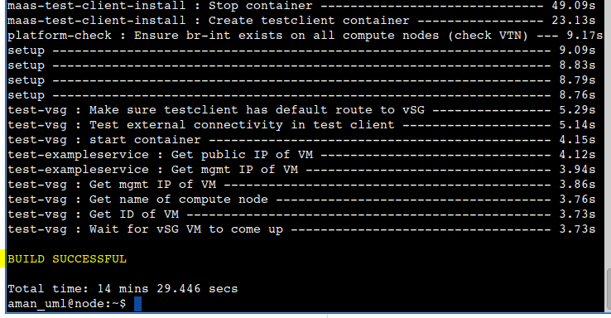

Now ssh into prod environment to see the list of services

* ssh prod

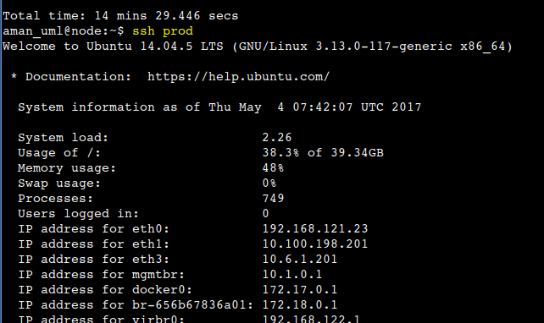

Verify the folders created

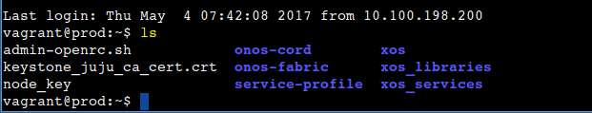

If everything goes well at this point, we are good to start the making changes in the hello world service.

Refer to the document ‘Running HelloWorld service and creating new tenant service’ [1] in the github repository to run example service.

References –

[1] CORD-in-a-Box Quick Start Guide

<https://github.com/opencord/cord/blob/cord-2.0/docs/quickstart.md>

[2] Project Documentation

<https://github.com/amanmaldar/EECE7290_Project>

<https://github.com/priyanka-N-Murthy/EECE-7290-Software-Defined-Networking-Project>